The Vault

David Jackson, Kaila Roberts, Ryan Grimes, Elali McNair, Madison Boyd, Day Ekoi



Requirements

Table of Contents

1.0 Introduction (Day Ekoi) 4
1.1 Goals and objectives 4
1.2 Statement of scope 5
1.2.1 Student Validation 5
1.3 Software context 7
1.3.1 AWS Services 8
1.4 Major constraints 9
2.0 Usage scenario ( Kaila Roberts) 10
2.1 User profiles 11
2.2 Use-cases 11
2.3 Special usage considerations 12
3.0 Data Model and Description (Elali McNair) 12
3.1 Data Description (Elali McNair) 12
3.1.1 Data objects (Elali McNair) 12
3.1.2 Relationships (Elali McNair) 13
3.1.3 Complete data model (Elali McNair) 13
3.1.4 Flow Diagram (Elali McNair) 14
3.1.5 Data dictionary (Elali McNair) 15
4.0 Functional Model and Description (David Jackson) 15
4.1 Description for Function n 15
4.1.1 Processing narrative (PSPEC) for function n 17
4.1.2 Function n flow diagram 19
4.1.3 Function n interface description (Ryan Grimes) 19
4.1.4 Function n transforms 20
4.1.4.1 Transform 1 description (processing narrative, PSPEC) (Ryan Grimes) 20
4.1.4.2 Transform 1 interface description (Ryan Grimes) 20
4.1.4.3 Transform 1 lower level flow diagrams 21
4.1.4.4 Transform 2 description (Ryan Grimes) 21
4.1.4.5 Transform 2 interface description (Ryan Grimes) 21
4.1.4.6 Transform 2 lower level flow diagrams (Ryan Grimes) 21
4.1.4.7 Transform 3 description (Ryan Grimes) 22
4.1.4.8 Transform 3 interface description (Ryan Grimes) 22
4.1.4.9 Transform 3 lower level flow diagrams (Ryan Grimes) 22
4.1.5 Performance Issues (Ryan Grimes) 23
4.1.6 Design Constraints (Ryan Grimes) 23
4.2 Software Interface Description (Ryan Grimes) 23
4.2.1 External machine interfaces (Ryan Grimes) 24
4.2.2 External system interfaces (Ryan Grimes) 24
4.2.3 Human interface (Ryan Grimes) 24
4.3 Control flow description (Ryan Grimes) 24
5.0 Behavioral Model and Description (David Jackson) 25
5.1 Description for software behavior 25
5.1.1 Events 25
5.1.2 States 26
5.2 State Transition Diagrams 26
5.3 Control specification (CSPEC) 26
6.0 Restrictions, Limitations, and Constraints 27
6.1 User and Access Restrictions 27
6.2 Functional Limitations 27
6.3 Technical and Platform Constraints 27
6.4 Security and Data Handling Constraints 28
6.5 Resource and Schedule Constraints 28
6.6 Collaboration and Tooling Constraints 28
6.7 Scalability Constraints 28
7.0 Validation Criteria (David Jackson) 28
7.1 Classes of tests (David Jackson and Ryan Grimes) 29
7.2 Expected software response 30
7.3 Performance bounds 30
8.0 Code Contributions and Description 30
8.1 David Jackson Code Contributions 30
8.2 Elali McNair Code Contributions 33
8.3 Madison Boyd Code Contributions 35
8.4 Ryan Grimes Code Contributions 36
8.5 Day Ekoi Code Contributions 37
8.5.1 Day Ekoi Coding Contributions - I4 38
8.5.2 Day Ekoi Coding Contributions - I5 39
8.6 Kaila Roberts Code Contributions 42
9.0 Revision Log (Madison Boyd) 45

1.0 Introduction (Day Ekoi)

This document provides an overview of The Vault, a Cloud-Based Campus Marketplace for Hampton University students. The system enables all users to securely login in, and more specifically student brand owners to create and manage storefront and listings, while allowing other students to browse through available items through a secure web interface.

The purpose of this document is to formally outline the data, functional, and behavioral requirements of The Vault. This document specifies what the system must accomplish, the constraints under which it operates, and the scope of the current project.

1.1 Goals and objectives

The main goals of The Vault are to:
- Provide users with a secure login system, with passwords stored using hashing.
- Allow users to manage storefront and listings
- Allow users to browse listings and view item details
- Allow customers to maintain a wishlist of desired products
- Maintain a record of products bought and sold by users (Purchase History)
- Support a return-handling process for completed purchases
- Store listing images securely using Amazon S3
- Maintain structured data in a cloud-based PostgreSQL database
- Provide a responsive and user-friendly web interface
- Support secure cloud deployment on AWS
- Support a complete checkout and order tracking system using an in-person exchange model

Objectives:
- Enforce consistent role-based authorization rules throughout the system
- Allow users to gain seller capabilities by creating a storefront
- Support listing inventory management, including size-based inventory tracking
- Maintain order history records for buyers and sellers
- Define a workflow for processing returns
- Preserve data integrity using soft-action logic where appropriate
- Provide consistent and structured error handling for invalid or unauthorized actions
- Prioritize security, maintainability, and usability throughout development

1.2 Statement of scope

The Vault provides Hampton University students with a centralized platform for promoting, browsing, and purchasing clothing items offered by student-owned brands.

The system operated under a unified account model where all users register under a single account type.

Users may function as:
- Shoppers, who can browse listings, maintain wishlists, complete purchases, and view purchase history
- Sellers, who gain additional permission after creating a storefront

Users are not required to create separate accounts to act as sellers. Upon successful storefront creation, that is when seller permissions are granted to the user for that storefront.

Admin users have higher privileges and permissions where they are allowed to manage storefronts and listings regardless of ownership.

1.2.1 Student Validation

To restrict system access to Hampton University students, user registration will enforce domain-based email validation rules.

The system must require that registered email addresses end with one of the following domains:
- @my.hamptonu.edu
- @hamptonu.edu

If the provided email does not meet this requirement, registration will be rejected and an error message will be returned.

This validation serves as a simplified access control mechanism appropriate for demonstration. Full institutional authentication is outside the scope of this project.

Major Inputs:
- User login credentials for authentication
- Storefront information (name, description, owner association)
- Storefront image uploads including banner, logo, and up to four preview images (stored in S3)
- Listing information (title, description, price, fulfillment type, inventory details)
- Listing image uploads (stored in S3 and referenced by URL)
- Cart actions including adding and removing items from the persistent shopping bag
- Checkout submission data including buyer contact details and meeting location
- Wishlist selections by customers
- Return request data including order number, reason, damage status, and optional damage image
- User actions such as creating, editing, deleting, browsing, purchasing, or requesting returns

Processing Functionality:

The system must:
- Authenticate and authorize users securely using hashed passwords.
- Enforce domain-based email validation for Hampton University accounts during registration.
- Authorize user actions using role-based access (user vs admin).
- Create, store, retrieve, update, and soft-delete storefront records, including brand name and descriptive information, ownership association, and active/inactive status.
- Create, store, retrieve, update, and soft-delete listing records, including title and description, price and fulfillment type, inventory quantity and availability status, and association to a specific storefront.
- Automatic inventory logic enforcement.
- Manage size-based inventory records for applicable listings.
- Store listing images in Amazon S3 and maintain image URLs within the database.
- Maintain persistent cart records per user and load cart state on login.
- Process checkout transactions by validating buyer details, generating a confirmation number, creating order and order item records, decrementing size inventory, clearing the cart, and removing purchased items from the wishlist.
- Maintain and retrieve wishlist records associated with user accounts.
- Maintain and retrieve purchase history records for buyers and sellers.
- Process and store return requests including optional damage image uploads to S3.
- Enforce ownership rules so that users can only modify their own listings.
- Provide search and filter features for browsing listings.

Major Outputs:
- A public catalog of active marketplace listings viewable by authorized users.
- User dashboards displaying managed storefronts and listings, wishlist items, purchase history, and account settings.
- Order confirmation page displaying confirmation number, order summary, and total amount.
- Admin management access for storefronts, listings, and returns.
- Error messages for invalid or unauthorized actions.

Scope Limitations:
- The system will not integrate with any other external marketplaces or platforms.
- Payment processing is not implemented. The checkout system uses an in-person exchange model where buyers submit contact details and a meeting location. Sensitive payment data is never collected or stored.
- Advanced analytics, AI features, and broader systems are outside the scope of this project/iteration.

The overall focus of this application is on delivering a secure, cloud-based, and user-friendly marketplace that meets the functional requirements for Hampton University students while remaining scalable for possible future expansion.

1.3 Software context

The Vault is designed to support Hampton University's student community by providing a centralized platform for buying and selling student brand clothing items. The Vault functions as a cloud-hosted web application prototype.

Strategic Context:
- The Vault will promote student-owned brands and provide an easy way for students to discover and purchase items
- Security, usability, and accessibility are top priorities to ensure trust and adoption by the student community
- The system is designed to be scalable, allowing for future expansion to include additional product categories or features

Technical Context:
The system will utilize the following features and technologies:

Software/Tool | Description | Type
AWS | Cloud platform for hosting the application, database, and backend services | Cloud Service
Python | Programming language for backend development. Will handle user authentication, database communication, and server-side processing. | Language
Flask | Python web framework used to build backend REST API, define routes, handle HTTP requests and responses, and enforce application logic | Framework
Javascript | Programming language to manage the frontend interface, enabling users to communicate with backend API endpoints through a web browser. | Language
HTML | Markup language used to structure and organize the content of the web pages, including forms, buttons, listings, and layout elements displayed in the user interface. | Language
CSS | Styling language used to control the visual design and layout of the web interface, including colors, spacing, alignment, and responsiveness. | Language
PostgreSQL | Relational database for storing structured system data, including users, storefront, listings, purchases, and related records. | Database
GitHub | Repository for version control and collaboration | Collaboration Tool
VS Code | Development environment used for coding, debugging, and testing the application | Application
Jira | Project management tool for tracking tasks, iterations, and milestones | Project Management
Google Drive | Cloud-based storage and collaboration platform for team documentation | File Sharing/Collaboration

1.3.1 AWS Services

The Vaults architect includes using a cloud-based, multi-tier design hosted within AWS infrastructure. The application layer, data layer, storage layer, and networking/security layers work together to provide controlled access, data persistence, and scalable deployment.

Service | Description | Implementation
AWS Elastic Beanstalk | Managed cloud service used to deploy and run the backend web application | Hosts the flask-based backend API that handles authentication, storefront and listing management, purchase logic and communication with AWS RDS and Amazon S3. Receives HTTPS requests from users’ browsers and executes server-side processing.
AWS RDS (PostgreSQL) | Manages relational database service used for structured data storage | Stores persistent data including Users, Storefronts, Listings, Listing Images, Listing Sizes, Orders, Order Items, Cart Items, Wishlist records, and Return records. The backend application communicates with RDS using SQL queries to create, retrieve, update, and delete records.
Amazon RDS Endpoint | Network connection endpoint provided by AWS RDS for secure database access | Supplies the hostname and port used by the Flask backend application to establish a secure connection to the PostgreSQL database instance
Amazon S3 | Cloud-based object storage service for storing unstructured files | Stores listing images separately from the database. The backend uploads images to S3 and saves the image URL in RDS for retrieval and display
AWS IAM (Identity and Access Management) | Identity and access management service used to control permissions within AWS | Manages administrative access to AWS resources and ensures that only authorized roles can access RDS, S3, and deployment environments
Amazon VPC (Virtual Private Cloud) | Isolated virtual networking environment within AWS | Provided network-level separation between infrastructure components and ensures controlled communication between the application and database layers.
Security Groups | Virtual firewall controls within AWS networking. | Restricts database access so that only the Elastic Beanstalk application environment can communicate with the RDS instance, preventing public access.

1.4 Major constraints

The development and deployment of The Vault must operate within several technical, resource, and collaborative constraints to ensure successful delivery within the given timeline.

Technical Constraints:
- AWS Credit Limitation: Each team member has access to $200 in AWS promotional credits. While this expands the total available cloud budget, deployment and testing must be coordinated across accounts to ensure efficient use of credits. Resources must be carefully configured and monitored to avoid unnecessary spending and to prevent exceeding individual credit limits.
- Cloud Infrastructure Configuration: The application relies on proper AWS configuration. Any misconfiguration of database access rules or IP restrictions may prevent successful deployment or connectivity.
- Listing Ownership & Role Enforcement: Users can only modify storefronts and listings associated with their account, while administrators have full access to manage all listings. Role-based access control must be consistently enforced at the application level.
- Cross-Platform Compatibility: The application must function consistently on modern web browsers across macOS and Windows
- Security Requirements: Passwords must be hashed and stored securely, and cloud deployment must follow basic security principles for access control and data protection.

Resource Constraints:
- Project Timeline: The Vault must be completed within the defined course timeline, with all development, testing, and documentation completed according to given deadlines
- Team Management: The team must utilize their time efficiently across development, testing, and documentation to ensure progress and on time deliverables

Collaboration Constraints:
- Documentation & File Sharing: All team members will use Google Drive for document storage and collaboration.
- Version Control & Task Management: GitHub will be used for source code management, and Jira will track tasks, iterations, and milestones
- Communication: Team members will communicate via iMessage and scheduled meetings to ensure accountability and coordination

These constraints guide the design, development, and deployment of The Vault, ensuring that the final application is reliable, user friendly, secure, and maintainable, while remaining exclusive to the Hampton University student population.

2.0 Usage scenario ( Kaila Roberts)

Users of The Vault will consist of Hampton University students who will be able to access the platform through a browser and application. All users will gain access to the application by registering for an account using verified university credentials and a secure username and password. Once authenticated, users will be directed to our homepage, where they will be able to browse the catalog for available clothing items from verified student brands. Shoppers will also be able to view details for each item as well as filter through the items. Student brand owners will be able to create an account for their businesses and create new listings by entering all the information on the clothing. Users are able to edit and delete any listing that they created, while administrators have permissions to manage all listings. After a user has successfully finished any task of their choosing, they can log off of the system securely.

2.1 User profiles

The Vault is made to support multiple user categories. Each category consists of different roles, permissions, and goals.
Student Shopper
The student shopper is a Hampton University student who will use the platform to browse the clothing listings given by the student brand owner. The goal of this user is to discover and view any available items posted by the brand owners. Shoppers can view listings, search and filter items, and message sellers, but they cannot modify listings.
Student Brand Owner
A student brand owner is a Hampton University student who manages and owns a clothing brand and contributes their brand to The Vault. The user is able to create, edit, delete, and add to the browser listing. Brand owners are responsible for maintaining the information for their products and managing their listings.
Administrator
An administrator is a user given privileges and responsibilities to oversee the system. Administrators are given access to all listings and can modify them (i.e., edit, remove, etc.) if any listings violate platform guidelines. This role ensures the system's integrity, policy is enforced, and overall platform management.

2.2 Use-cases

The following use-cases represent the primary interactions users have with The Vault:
- User registers for an account using Hampton University credentials or similar
- User logs into the system using a secure username and password
- Student shopper browses and searches marketplace listings
- Student brand owner creates a new clothing listing
- Student brand owner edits an existing listing they own
- The student brand owner deletes a listing they own
- Administrator views, edits, or deletes any listing
- User logs out of the system securely

2.3 Special usage considerations
Users may only modify or remove any entries or listings that they created, whereas administrators have full access to modify any listing created. Due to deployment on the AWS Free Tier, the system performance, storage, and security must remain efficient. Any security consideration, such as access control, password hashing, and session management are enforced so user data remains secure and protected.

3.0 Data Model and Description (Elali McNair)

The two sets of data our system will be collecting is the user’s login information and the listings the users will create or edit. The user’s login information will consist of their usernames and passwords.

3.1 Data Description (Elali McNair)

Although the usernames and passwords will be saved to allow the feature of creating an account, the listings will be the primary data that will be regularly created, edited, or deleted by the users or the staff.

3.1.1 Data objects (Elali McNair)

The usernames and passwords collected will be string data types while the listings will be objects created by the users or staff of the system.

3.1.2 Relationships (Elali McNair)
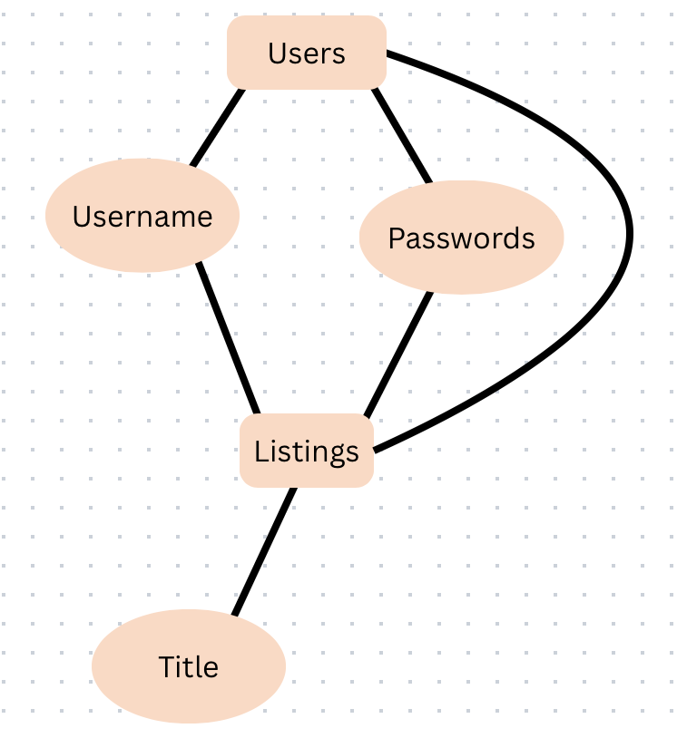

3.1.3 Complete data model (Elali McNair)

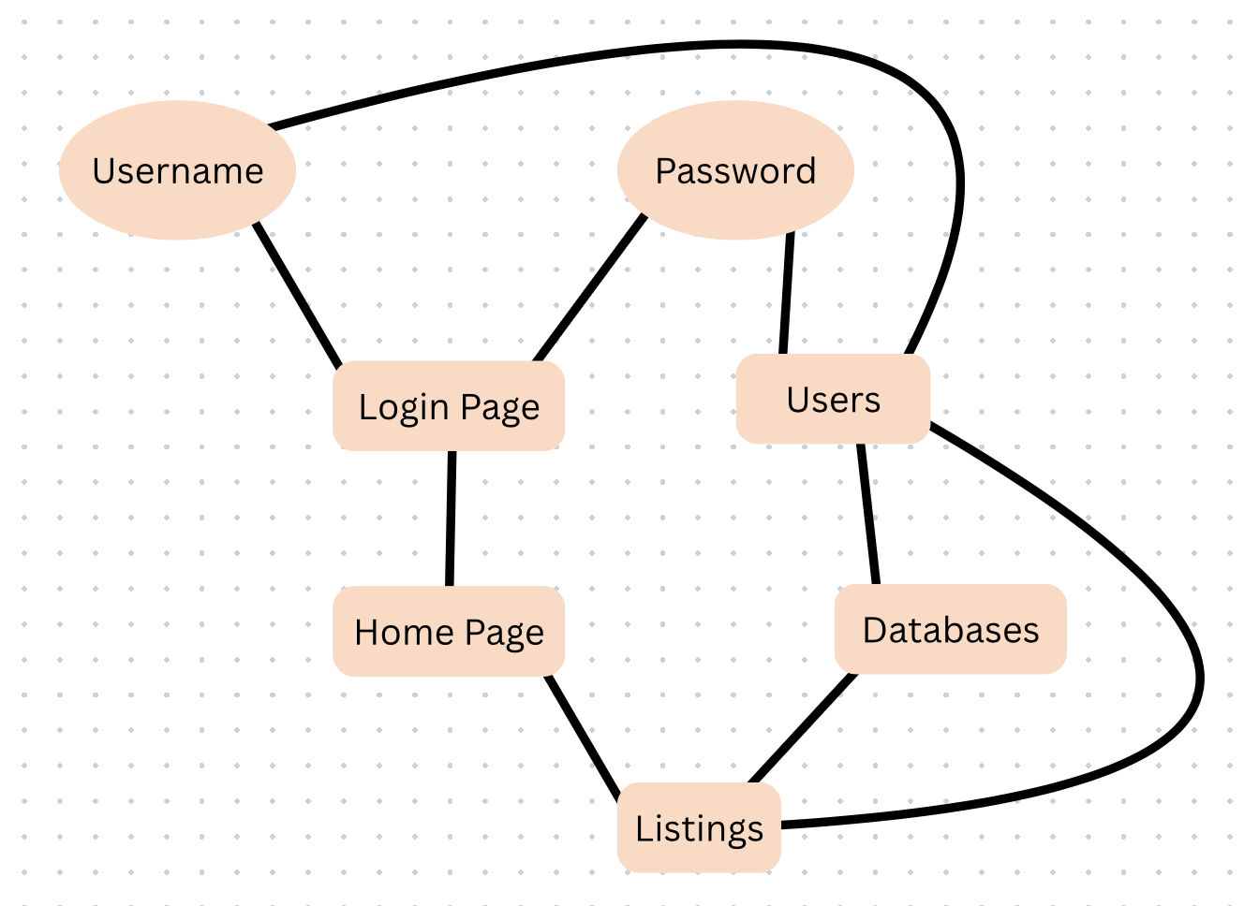

3.1.4 Flow Diagram (Elali McNair)

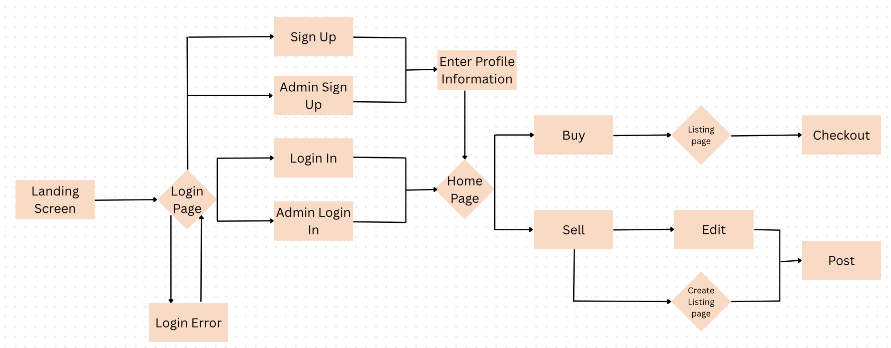

When entering the marketplace the user will be brought to the login page and have an option to either “sign up” or “login”. If the user is an admin, they will have a separate set of information to enter. If the user attempts to sign up, they will be brought to the profile screen and be prompted to enter their new user information. Once they finish their user will be created and saved while they are brought to the home page of the marketplace. If the user already has an account and chooses to login, they will be brought straight to the home page. If the user enters the wrong information, they will remain at the login screen and be prompted to enter the correct information carefully to avoid errors. Once the user is in the home page they have an option to search to buy or sell listings. If they choose to buy, they are brought to a general listings page and are free to select whatever they like. Once they select their item and are done searching they can head to the checkout page to place their order. If the user chose to sell a listing, they would first have the option to either edit a listing they have already posted or create a new one. After the user chooses their desired route they will post the listing and be brought back to the home page.

3.1.5 Data dictionary (Elali McNair)

- Users (Admin, Username, Password)
- Listings (Users, Title)
- Prices(Listings, Amount)

4.0 Functional Model and Description (David Jackson)

This section describes the functional breakdown of the Vault system, including processing logic, interfaces, data flow, performance considerations, and constraints. The system follows a client-server architecture deployed on AWS using Elastic Beanstalk for application hosting and Amazon RDS (PostgreSQL) for database services.

4.1 Description for Function n

The major system functions include:

User registration:

The User Registration function allows new Hampton University students to create an account within the Vault system. This function collects required user information, encrypts sensitive credentials, and stores the user record securely in the database.

The system ensures that:
- No duplicate accounts exist
- Passwords are securely hashed before storage

Successful registration creates an account and grants access to authentication services(login/logout). If validation fails, appropriate error messages are returned.

User authentication (login/logout):

The User Authentication function manages secure access to the marketplace. It verifies user credentials by comparing submitted login information with encrypted records stored in the database.

Once authenticated:
- Users gain access to the system
- A secure session is created

Create listing:

The Create Listing function allows authenticated users to post fashion items for sale within the marketplace. Users provide item details such as name, description, price, category, and upload an image.

The system:
- Validates all required fields
- Stores listing information in the database
- Makes the listing visible in the marketplace feed

Edit/delete listing:

The Edit Listing function allows users to modify the details of listings they have previously created. The system verifies listing ownership before permitting changes. The Delete Listing function allows the user to permanently delete the listing from the marketplace.

User can update/edit:
- Item description
- Price
- Category
- Availability status

Once deleted:
- The listing record is removed or marked inactive in the database
- The item no longer appears in search results or the marketplace feed

Browse & search listings:

The Browse Listings function allows users to view available fashion items posted by other students. The system retrieves active listings from the database and displays them in a structured and organized format. The Search and Filter function allows users to refine marketplace results using keywords and filtering criteria.

Listings can be sorted by:
- Most recent postings
- Price
- Category

Users will be able to search:
- Item name
- Price range
- Category
- Availability status

Admin management:

The Admin Management function allows authorized administrative users to moderate the platform.

Admins can:
- Remove inappropriate listings
- Suspend user accounts
- Monitor system activity

Purchase & checkout:

The Purchase or Checkout function allows a buyer to confirm interest in purchasing an item. When triggered, the system:
- Verifies item availability
- Updates listing status to “Sold”
- Prevents duplicate purchases
- Notifies the seller

4.1.1 Processing narrative (PSPEC) for function n

A processing narrative for function n is presented.

User registration:

When a user selects “Register,” the system:
- Accepts input data (name, email, password)
- Validates email format and ensures it belongs to the Hampton University domain
- Checks for duplicate accounts in PostgreSQL (RDS)
- Encrypts the password using secure hashing
- Stores user information in the Users table
- Returns confirmation or error message

User authentication(login/logout):

- User submits email and password.
- The system retrieves the stored password hash from RDS.
- Compares the input password with the hashed value.
- If valid, generates a secure session token.
- Grants access to marketplace features.

Create listing:

- Authenticated user selects “Create Listing.”
- User inputs:
  - Item name
  - Description
  - Price
  - Category
  - Image upload
- System validates required fields
- Stores listing in Listings table in RDS
- Uploads image to AWS storage (S3). Displays listing in the marketplace feed

Edit/delete listing:

- User selects the listing they own
- System verifies ownership
- Allows modification or deletion
- Updates or removes listing from RDS

Browse & search listings

- User accesses homepage
- System retrieves active listings from RDS
- Displays listings sorted by most recent
- Search filters apply SQL query filters (price, category, keyword)

Admin management:

Admin users can:
- View all listings
- Remove inappropriate content
- Suspend user accounts

Purchase & checkout:

- User selects item
- Confirms purchase
- System verifies listing availability
- Marks item as sold in the database
- Notifies seller

4.1.2 Function n flow diagram

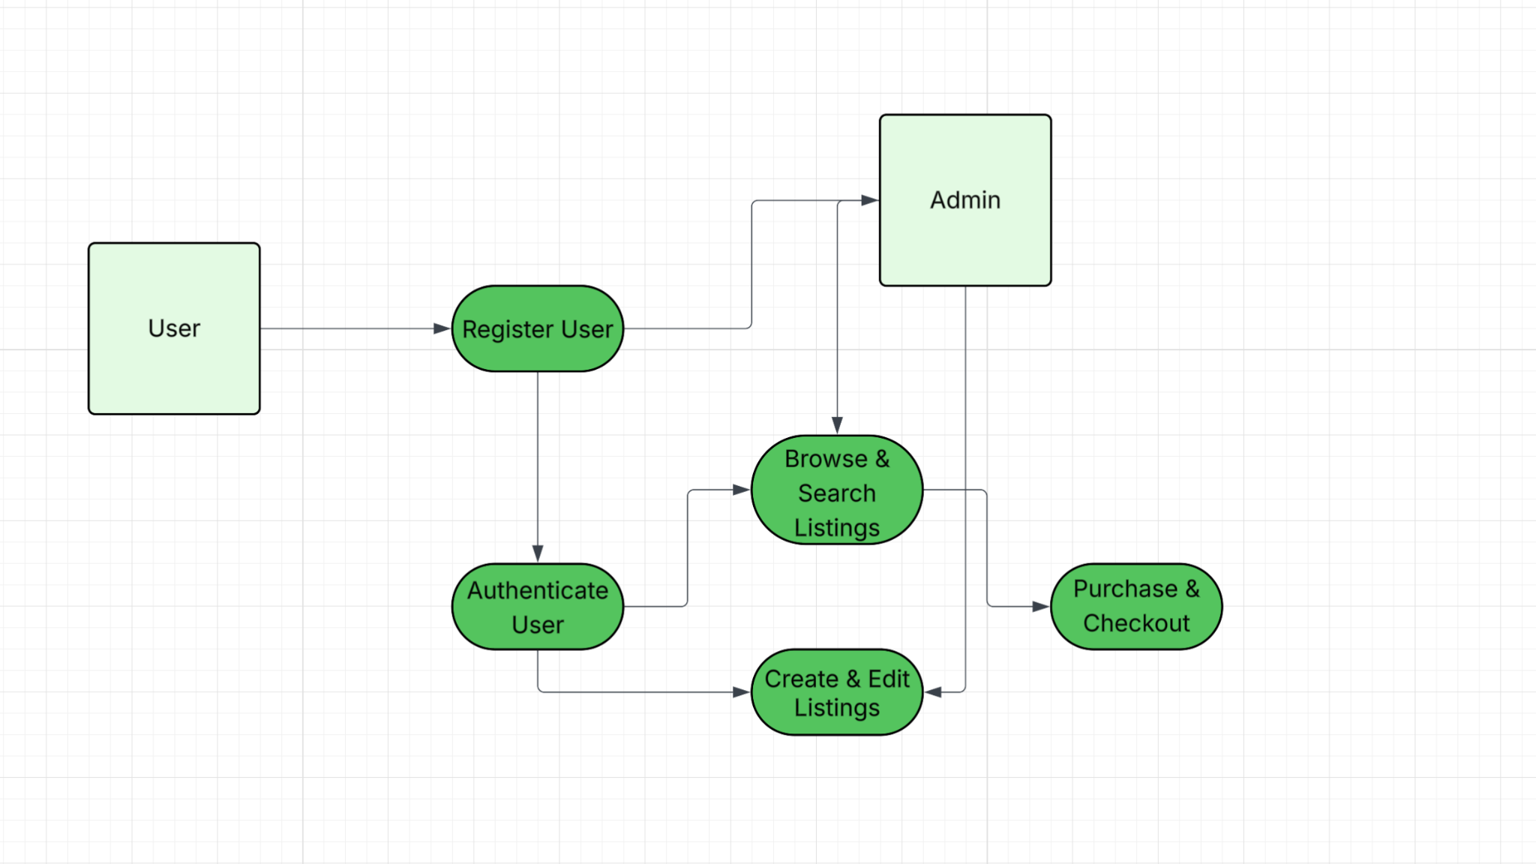

4.1.3 Function n interface description (Ryan Grimes)

A detailed description of the input and output interfaces for the function is presented.

- Input interface: JSON is a list of keys and values. During, the input interface expects three pieces of input: email, username, and password. If the data type doesn’t match the JSON rules, such as a phone number being inputted instead of an email, the interface rejects it at the window before it reaches the database.
- Output interface: If the login is successful, a 200 code response is sent back along with routing to the listing screen. But, if the login fails, a 401 error will be sent.
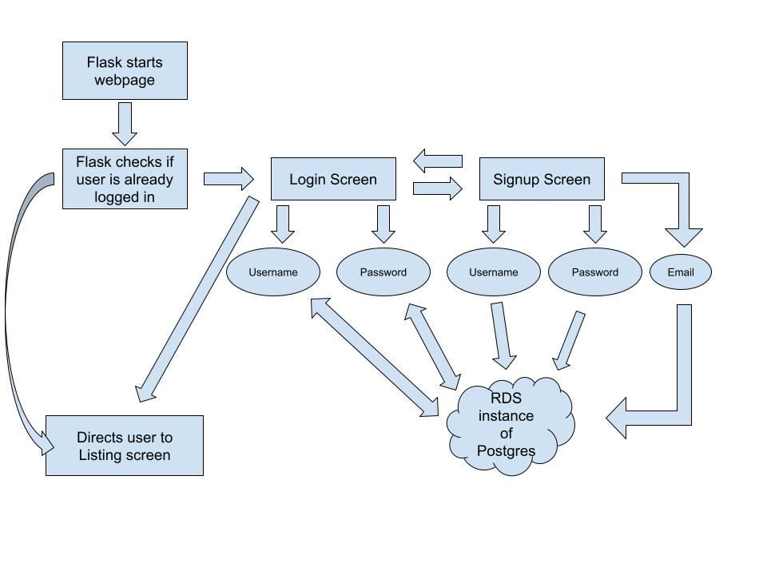

4.1.4 Function n transforms

A detailed description for each transform (subfunction) for function n is presented. Section 4.1.4 is repeated for each of k transforms.

4.1.4.1 Transform 1 description (processing narrative, PSPEC) (Ryan Grimes)

This transform manages how students join and enter the marketplace.

During registration, the system accepts a name, email, and password. During this process, the system ensures the email belongs to the Hampton University domain (@hamptonu.edu), the username/email isn’t a duplicate, and the password is hashed before storing it in the PostgreSQL database on AWS RDS.
When logging in, the system retrieves the stored hash and compares it to the input password. If they match, a secure session token is generated to grant access to the site’s features.

4.1.4.2 Transform 1 interface description (Ryan Grimes)

For the input interface, the system expects a JSON list containing the user’s email, username, and password. If the data types are incorrect, the interface rejects the input before it even reaches the database.
For the output interface, a “200” success code is returned during a successful login and routes the user to the listing screen. A failed login sends a “401” error code.

4.1.4.3 Transform 1 lower level flow diagrams

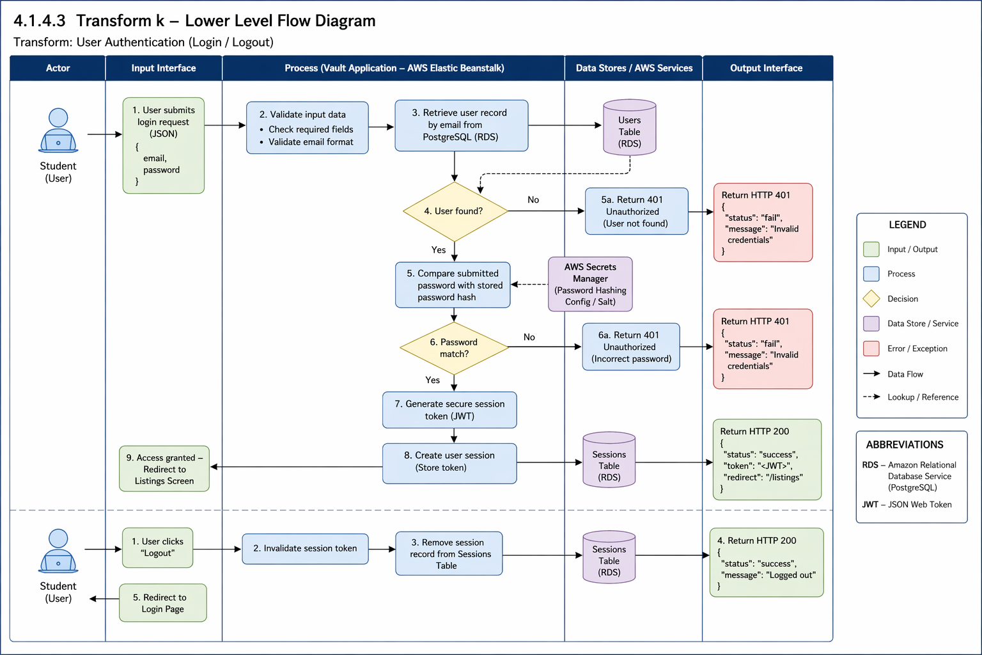

4.1.4.4 Transform 2 description (Ryan Grimes)

This transform handles how brand owners control their products.

During listing creation, authenticated users input an item’s name, description, price, and category. The system validates the fields, stores the details in the RDS database, and uploads the product image to Amazon S3 storage.
When it comes to edits and deletion, the system verifies that the user is the actual owner of the listing before allowing any modifications or deletions. If deleted, the record is removed or marked inactive so it doesn’t appear in the feed anymore.

4.1.4.5 Transform 2 interface description (Ryan Grimes)

For the input interface, item details (title, price, availability status) are provided during listing creation. For the output interface, a public catalog of active listings and updated user dashboards showing their managed storefront is displayed.

4.1.4.6 Transform 2 lower level flow diagrams (Ryan Grimes)

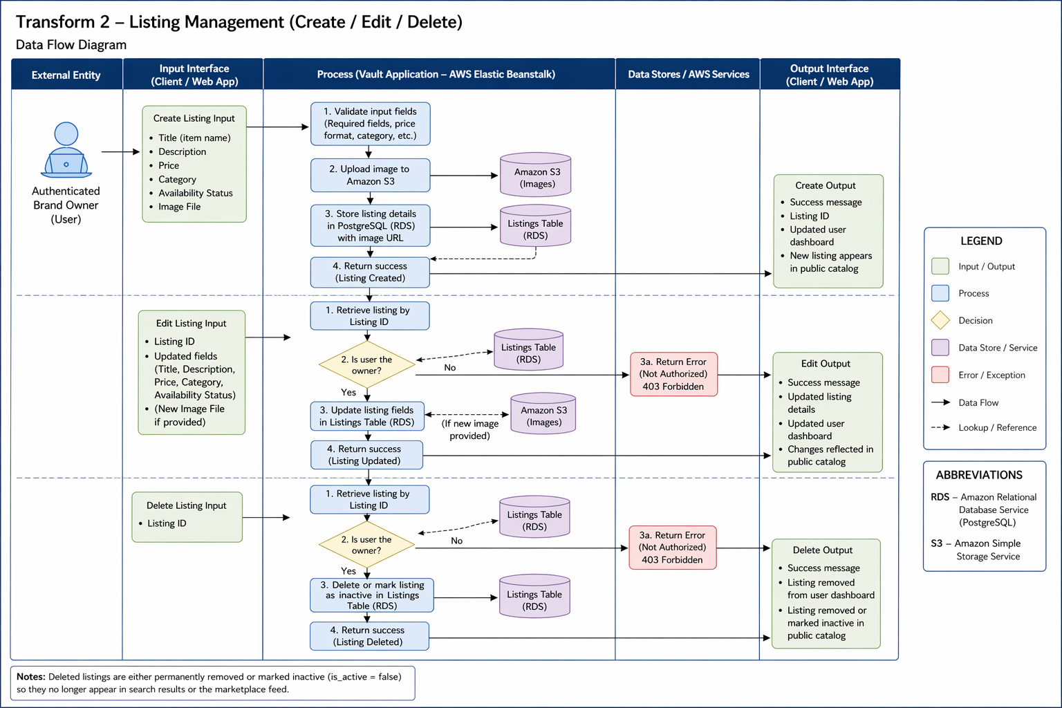

4.1.4.7 Transform 3 description (Ryan Grimes)

This transform handles the final transaction phase where a student buyer confirms their interest and purchases the item from the marketplace.

During purchase, the system queries the listings table to ensure the availability_status is still active to ensure concurrent purchases of a unique item. Once availability_status is verified, the backend executes a SQL UPDATE command to change the item’s status to sold. The system then records the transaction details and links the buyer’s user_id to the listing_id in a history table. Finally, the system clears the item from the user’s cart.

4.1.4.8 Transform 3 interface description (Ryan Grimes)

The inputs are the User_ID of the buyer and the Listing_ID of the specific item being purchased, and the outputs are the updated “Sold” status in the database, a confirmation message to the buyer, and a notification sent to the seller. In addition, the item is removed from other users’ feeds.

4.1.4.9 Transform 3 lower level flow diagrams (Ryan Grimes)

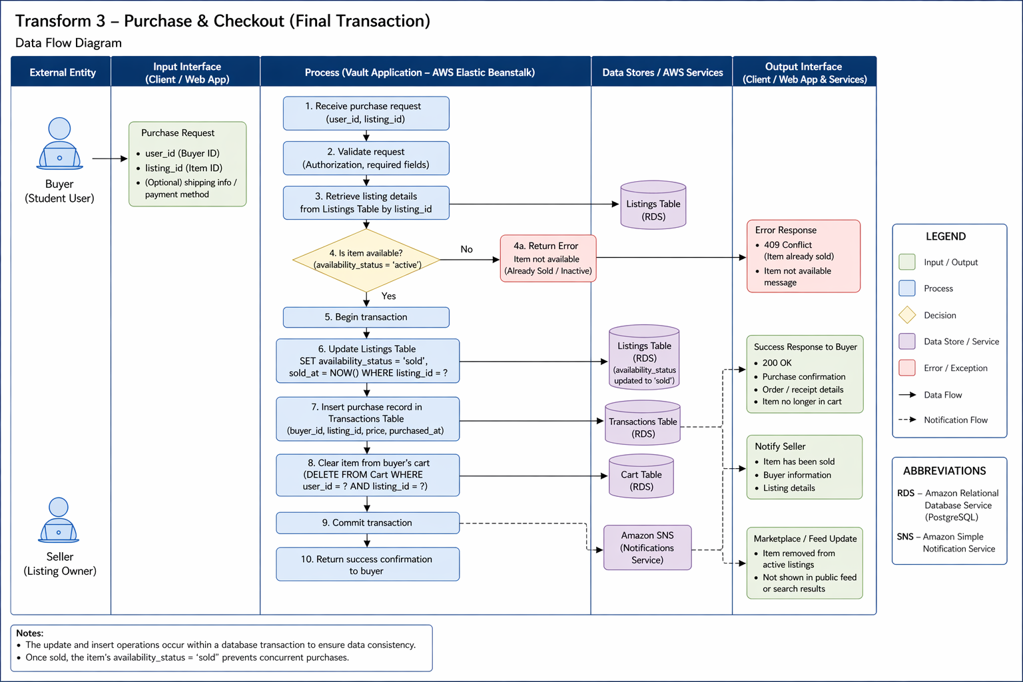

4.1.5 Performance Issues (Ryan Grimes)

Special performance required for the subsystem is specified.

- Latency: Requests must travel from the user to the AWS RDS instance in us-east-1. The goal is to stay under 200ms query response times.
- Concurrency: The system should be able to handle multiple simultaneous user inputs without locking database rows.

4.1.6 Design Constraints (Ryan Grimes)

Any design constraints that will impact the subsystem are noted.

- Cloud security: The system is constrained by the AWS Security Group Inbound Rules. These only accept traffic from authorized IP addresses.
- Statelessness: Sessions are stored in secure cookies instead of files to allow scalability in Flask.

4.2 Software Interface Description (Ryan Grimes)

The software interface(s)to the outside world is(are) described.

4.2.1 External machine interfaces (Ryan Grimes)

Interfaces to other machines (computers or devices) are described.

- Psycopg2 communicates to AWS RDS over port 5432. This connection is initialized in init_db.py and tested in db.py.

4.2.2 External system interfaces (Ryan Grimes)

Interfaces to other systems, products or networks are described.

- AWS RDS: The Vault uses AWS RDS as a global database. The backend uses the psycopg2 adapter to open a secure communication channel over the TCP/IP network on port 5432 to the AWS PostgresSQL instance. This connection is protected by an AWS Security Group that only allows communications from explicitly approved IP addresses.
- Internet Browser: The server interfaces with the browser using JSON for data and HTML/CSS for visuals.

4.2.3 Human interface (Ryan Grimes)

An overview of any human interfaces to be designed for the software is presented.

- Web GUI: A webpage at https://127.0.0.1:5000 will contain the webpage frontend.
- Admin CLI: init_db.py allows for direct database schema management.

4.3 Control flow description (Ryan Grimes)

The control flow for the system is presented with reference to Section 5.0 of this document.

- Entry: Requests go to app.py.
- Routing: app.py delegates to a routing blueprint.
- Logic: The controllers validate the formatting of the requests and hand it to the services.
- Data: The services request data from the models, the models execute the SQL commands on the AWS RDS.
- Exit: Data flows back up the chain and is returned to the user as JSON.

VIEW
MODEL
CONTROLLER

5.0 Behavioral Model and Description (David Jackson)

(Section 5 will be addressed starting on iteration 2 and continuing through the remaining iterations.)

A description of the behavior of the software is presented.

5.1 Description for software behavior

This section describes the dynamic behavior of The Vault system, including the major system states and the events that trigger transitions between those states. The behavioral model illustrates how the system responds to user interactions, administrative actions, and internal validation processes.
The Vault operates as an event-driven, web-based system in which user inputs initiate system processing. The system transitions between defined operational states based on authentication status, user activity, and administrative privileges.

5.1.1 Events

Event | Description
Register Submitted | User provides information to register
Login Submitted | User tries logging in
Create listing clicked | User begins creating their listing
Submit listing | User submits their listing
Edit listing clicked | User edits their listing
Delete listing clicked | User removes their listing
Search performed | User searches for specific listings
Purchase confirmed | User confirms purchase
Admin remove | Admin removes a listing
Logout | User ends session and leaves the webpage

5.1.2 States

The system operates under the following primary states:
- Unauthenticated State
- Authenticated State
- Viewing Marketplace
- Creating Listing
- Editing Listing
- Checkout State
- Admin State

5.2 State Transition Diagrams

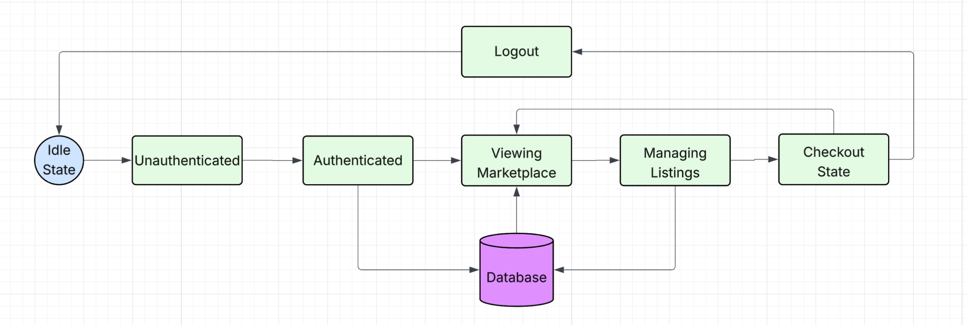

5.3 Control specification (CSPEC)

The system uses event-driven control logic:
- User input triggers events.
- Backend validates state.
- If valid, state transition occurs.
- If invalid, error state is returned.
Security control rules:
- Only authenticated users may create/edit/delete listings.
- Only admin users may remove content.
- Session timeout returns system to Unauthenticated state.

6.0 Restrictions, Limitations, and Constraints

This section outlines the critical restrictions, limitations, and constraints that impact the design, implementation, deployment, and operation of The Vault. These components stemmed from evaluating the technical environment, security requirements, availability of resources, and Hampton University. Understanding these limitations ensures realistic expectations and helps guide design decisions throughout development.

6.1 User and Access Restrictions

The Vault is specifically geared towards university students. Even though students are allowed access to register, log in, and interact with the system they will not have admin access features to the marketplace. This restriction prevents any accidental data breaches for the users and provides an extra layer of security for the data being collected by the staff. Only emails ending in (hamptonu.edu) will be allowed to access The Vault to ensure that it is only Hampton University students accessing.

6.2 Functional Limitations

The Vault’s scope is limited to a basic campus marketplace for clothing items. Certain features commonly used in online marketplaces are excluded from this version of the system for this iteration/project. These limitations are: no integration with external e-commerce platforms or third party marketplaces, no advanced analytics, artificial intelligence, or recommendation systems.

These functional limitations ensure the project is manageable and meets course requirements and deadlines.

6.3 Technical and Platform Constraints

The system must be deployed using AWS Free Tier, which creates limitations on storage capacity, service usage, and computing resources. Because of this, the system design must prioritize efficient utilization of resources and avoid unnecessary activities.

The application must function as a web based system supporting operating systems such as macOS and Windows platforms. Backend development is constrained to python and Javascript while the database layer is constrained to PostgreSQL and MySQL.

6.4 Security and Data Handling Constraints

Security requirements create more constraints and restrictions to the system design. All user passwords must be hashed before storage and no plaintext credentials are kept. Access to sensitive data must follow basic cloud security practices that are efficient and safe such as proper authentication, authorization, and access control.

The system also limits data collection to what is necessary for key functionality like usernames, passwords, and listing information. This constraint is necessary to reduce risk exposure and establish responsible data handling. Also to keep compliant with security standards of Hampton University’s student systems.

6.5 Resource and Schedule Constraints

The creation of The Vault is constrained to the course timeline, which requires all design, implementation, testing, and documentation to be completed within iteration deadlines. This limits the features that can be implemented.

6.6 Collaboration and Tooling Constraints

All documentation and collaboration is limited to google drive for documentation, GitHub for uploading code, and Jira for project timeline and plan. Communication is done by in person meetings, phone calls, and apple Imessage group chat. This requires consistent communication and collaboration and clarity of schedules and expectations.

6.7 Scalability Constraints

The current implementation of The Vault is constrained to a single campus deployment and limited features. Expansion to other campuses and services is outside the scope of this project and would require more resources, time, and security.

7.0 Validation Criteria (David Jackson)

Login Page
- Users are able to create an account
- Users are able to login to their already existing account
- The account login information will be stored into the database
- Once the login process is complete, the user will be brought to the listing page
Listings Page
- Users can view several different listing posted
- Users can create their own listing
- Users can edit their existing listing
- Users can select to buy a listing
- All user-created listing information will be stored into the database
- After the user selects to buy a listing, they will be brought to the checkout section
Checkout Page
- Users can confirm their purchase and submit their payment

7.1 Classes of tests (David Jackson and Ryan Grimes)

- Unit Testing: This is when a tester tests small chunks of code, like a single function or method, to make sure it does what it’s supposed to. The goal is to confirm that the logic the developer wrote works the way they intended (GeeksforGeeks, 2025). This will be easily implemented by the Vault because programmers will test functionality before changes are committed to the shared repository.
- Integration Testing: This type of testing checks how different pieces of the software work together. It makes sure that data flows correctly between components and that nothing breaks when modules are combined (GeeksforGeeks, 2025). This will consistently be implemented individually and collaboratively by validating changes before commitment and validating changes on each individual’s desktop after commitment.
- System Testing: Once everything is integrated, system testing looks at the entire application as a whole. It checks if the full system meets the requirements and works the way it’s supposed to (GeeksforGeeks, 2025). This won’t be as heavily desired since a finished, working product isn’t expected by the customer.
- Black-Box Testing: In black-box testing, the tester doesn’t need to know how the system is built on the inside. They just provide inputs and check the outputs. This helps reveal how the system reacts to different user actions, whether expected or not, and can point out issues with usability, reliability, or performance. Common types include functional, non-functional, and regression testing (GeeksforGeeks, 2025;Imperva, n.d.). This may be difficult to implement because everyone is a programmer, so we’re expected to know how the system is built on the inside. To mitigate this issue, we can have individuals who did not code the tested functions test the functions.
- White-Box Testing: In white-box testing the tester has full access to the code, structure, and configuration. It checks the logic, data flow, and error handling to make sure everything inside the program runs the way it should (GeeksforGeeks, 2025; Imperva, 2025). This will be heavily and consistently used throughout coding. White-box testing should be done by every member of the team, and the software lead should do a very in-depth white-box testing.
- Security Testing: Ensures compliance with data protection policies and safeguards against vulnerabilities such as injection attacks or data leakage. Testing must also include penetration testing, and input validation checks.
- Functional Testing: Verifies that all specified functionalities operate as expected. Edge cases must also be tested.
- Usability Testing: Confirms that the system offers a clear and accessible interface.
- Scalability and Stress Testing: Verifies the system’s ability to handle large volumes of data and spikes of traffic without significant performance degradation.

7.2 Expected software response

- Scalability: Ability to process high volumes of listings and users.
- Security Compliance: No unauthorized access to restricted data or features, encrypted storage of sensitive data.
- Usability: Clear and accessible interface, ensuring seamless user interactions.
- Fault Tolerance: The system must be able to remain stable during unexpected failures, with automatic recovery and fallback mechanisms.

7.3 Performance bounds

- Admin Security: Only authorized users should be able to access that admin page.

8.0 Code Contributions and Description

8.1 David Jackson Code Contributions
Iteration 3 code contributions include three backend files added and one modified in order to support administrative functionality in the Vault project. These updates allow authorized administrators to monitor activity on the platform and remove inappropriate users or listings. The purpose of these changes is to implement a structured admin control system using the existing backend architecture.
Files created/added to:
- admin_controller.py
- admin_service.py
- admin_model.py
- app.py

admin_controller.py
This file defines the API endpoints that allow administrators to interact with the system. It creates a Flask Blueprint called admin_bp, which groups all admin-related routes under the /admin URL prefix. The controller receives HTTP requests from the frontend and calls the appropriate service functions to process the request. These routes allow administrators to retrieve all users, delete users, retrieve all listings, delete listings, and view storefronts. The controller also ensures that only authorized administrators can perform these actions before forwarding requests to the service layer. Once the request is processed, the controller returns the results to the frontend in JSON format.

admin_service.py
The service layer contains the business logic that supports administrative actions. It acts as the middle layer between the controller and the model. The service validates input parameters, enforces any rules for administrative operations, and calls the model functions that interact with the database. For example, when an admin requests to delete a user or listing, the service verifies that the required ID was provided before passing the request to the model. This separation helps maintain clean architecture by keeping validation and system rules out of the database layer.

admin_model.py
This file manages all database-level operations related to administrative functionality. It connects to the PostgreSQL database using the shared database connection defined in db.py. The model executes SQL queries to retrieve or modify data in the database. The functions in this file allow administrators to retrieve all users, retrieve all listings, retrieve storefronts, and permanently delete users or listings. The model layer focuses strictly on database interaction and does not contain any business logic.

app.py
The app.py file was modified to register the new admin routes with the Flask application. Specifically, the file imports the admin_bp Blueprint from controllers.admin_controller and registers it using app.register_blueprint(admin_bp). This step is necessary because Flask applications must explicitly register Blueprints before their routes become accessible. Without this change, the admin endpoints such as /admin/users or /admin/listings would not be recognized by the application. Registering the Blueprint integrates the admin functionality into the existing backend API structure alongside the listing and storefront routes.

Iteration 4:
Iteration 4 code contributions include three frontend files added and two modified in order to support administrative functionality in the Vault project. These updates created the frontend for the previous admin backend files created in the last iteration. Allow authorized administrators to monitor platform activity and remove inappropriate users or listings. The purpose of these changes was to implement a user-friendly UI that users with admin access can use to effectively complete admin activities.

Files created/added to:
- admin_dashboard.html
- admin.css
- admin.js
- auth_controller.py
- admin_controller.py

admin_dashbaord.html
This file defines the structure and layout of the admin dashboard interface. It creates a simple webpage with three main sections: Users, Listings, and Storefronts. Each section includes a button that lets the administrator load data from the backend, and a table that displays it dynamically. The file links to the external CSS file for styling and the JavaScript file for functionality. Overall, this file serves as the main user interface that administrators interact with after logging in.

admin.css
This file controls the visual styling of the admin dashboard. It defines the overall look and feel of the page, including the light gray background, white section containers, table formatting, and button styles. It also includes specific styling for delete buttons, making them red. The purpose of this file is to improve the readability and organization of the dashboard without affecting its functionality.

admin.js
This file handles the dynamic functionality of the admin dashboard by interacting with the backend API. It contains functions that send HTTP requests to retrieve users, listings, and storefronts, as well as functions to delete users and listings. After receiving data from the backend, the JavaScript dynamically updates the HTML tables to display the information. This file makes the dashboard interactive and ensures administrators can perform actions without reloading the page.

Iteration 5:
Iteration 5 code contributions included 2 completely new files, admin_login.html and test_admin.py. It also included updates or modifications made to 8 other code files with the purpose of improve both functionality and appearance of the admin dashboard. The purpose of these new files and updates were to incorporate a login page for admin users of The Vault, as well as expand on our previous version of the admin dashboard that was lacking in depth.
Files created/added to:
- test_admin.py
- admin_login.html
- Auth_controller.py
- admin_model.py
- admin_dashboard.html
- login.html
- admin.css
- admin.js
- auth_controller.py
- admin_controller.py

test_admin.py
This file contains both unit tests and integration tests for the admin dashboard functionality. The unit tests verify that routes, authentication, and API responses behave correctly by simulating requests and using controlled test data. The integration tests connect to the real PostgreSQL database and confirm that operations such as deleting users, listings, and storefronts actually modify the database as expected.

admin_login.html
This file defines the structure and layout of the administrator login page. It provides a dedicated interface separate from the standard user login, allowing administrators to securely authenticate before accessing the admin dashboard. The page includes input fields for username and password, styled consistently with the existing application theme to maintain a unified user experience.

8.2 Elali McNair Code Contributions

Elali was responsible for creating the backend portion of the wishlist and purchase history features for The Vault marketplace product. Due to the frontend portion of the features not being ready to be implemented yet, the code will have to remain unused and inoperational for now.
Files Created/Added to:
- Init_db.py
- app.py
- wishlist_service.py
- purchase_service.py
- wishlist_model.py
- purchase_model.py
- wishlist_controller.py
- purhcase_controller.py
The service, model, and controller files were created not only for connectivity with the corresponding data tables but also serves as a setup placement for the frontend portion of the code. The wishlist and purchase history features will be active in nearly every part of the marketplace, either due to UI design or data recall with the listing data structures. Since both features will be created and regularly updated by the user they were added to the services folder and perform similar to the listing_service.py file. With the same reasoning and purpose, these features were added to the model and controller folders as well due to the constant potential editing or updates the user will make. The additions to the init_db.py were to serve as the initial data tables the user’s entered information will be saved as, while the app.py additions were made to check the features functionality during the creation of the application.

Iteration 4
Elali was responsible for creating the front end portion of the “Create Listing" feature, “Wishlist” feature, and “Purchase History” feature for The Vault marketplace product. Now that the frontend portion of code has been created and implemented the backend portion of code for all three of these features is operational along with the frontend portion.
Files Created/Added to:
- app.py
- listing_controller.py
- Storefront_controller.py
- create_listing.py
- create_storefront.css
- storefront_view.css
- create_listing.js
- storefront_view.js
- account.html
- create_listing.html
- storefront.html
- storefront_view.html
App.py, listing_controller.py, storefront_controller.py, create_storefront.css, storefront_view.css, storefront_view.js, account.html, storefront.html, and storefront_view.html were all edited to route properly to my backend portion of code and the files I created. Create_listing.py, create_lisitng.js, and create_listing.html were created this Iteration to complete the frontend portion of these features. The “storefront” files, along with account.html and app.py, were edited to properly implement the “Wishlist” feature. The “listing” files, along with account.html, app.py, and listing_controller.py were edited if not created to properly implement the “Create Listing” feature.

Iteration 5
Elali was responsible for creating the test files for the “Create Listing” and “Wishlist” features. Along with the test files, Elali also made functional edits to both of these features as well.
Files Created/Added to:
- Listing_controller.py
- Requirements.txt
- Storefront_view.css
- Create_listing.js
- Storefront_view.js
- Create_listing.html
- Test_create_listing_feature.py
- Test_wishlist_feature.py
Listing_controller.py, Requirements.txt, Storefront_view.css, Create_listing.js, Storefront_view.js, and Create_listing.html were all edited to change the wishlist icon to make it more appealing and to make sure the listings being created or edited were saved and properly updated regularly. The new files created were test_create_listing_feature.py and test_wishlist_feature.py. They were test files created to check if both features were working properly and performing their tasks.

8.3 Madison Boyd Code Contributions

Madison was responsible for the User Settings, implementing a modular design the manage user preferences and application configuration. She created the module using the MVC (model view controller) and service pattern to ensure separation and modularization of the application. She created a data model to define settings attribute, a controller to manage user driven requests, and a service layer to facilitate file I/O operations and persistence. Additionally, she implemented a testing file to validate data integrity, ensuring the application correctly handles both valid user inputs and invalid edge cases during file operations.

Files Created/Added to:

- usersettings.py the core service file responsible for reading, writing, and persisting user configuration data to the local file system, added usersettings.py file in models to define the structure and data attributes for the user settings object. Added a usersettings.py file in controller to manage the interface between the user/UI and the settings logic, routing requests to the correct services. I added a usersettings.py in the services folder which summarizes the logic and file handling procedures for the settings module.
- usersettingstest.py testing file that validates the settings logic, including input validation and file integrity checks

Iteration 4

Madison was responsible for designing and implementing the Account Screen for The Vault front-end, focusing on creating an intuitive and user-friendly interface for managing user activity. She developed the account.html file to structure and display key user information, including listings, wishlist, purchases, and sales history. The interface was designed using a tab-based navigation system, allowing users to seamlessly switch between different categories of their account data.
She ensured the layout clearly presents the user’s username at the top of the screen, showing personalization and user context. Additionally, she incorporated navigation functionality that allows users to easily return to the storefront or log out of their account.
Files Created/Added to:
- account.html – Core front-end file responsible for structuring the Account Screen UI, including tab-based navigation for user listings, wishlist, purchases, and sales history. Also includes display elements for the username and navigation options such as returning to the storefront and logging out.
Iteration 5:
Madison expanded her contributions by enhancing the testing and validation of the Settings functionality for The Vault, with a focus on ensuring reliability and integration with other account features. She updated the usersettingstest.py file to include additional unit and integration tests that verify both core settings behavior and its interaction with the broader application.
She implemented tests to confirm that account screen buttons displayed within the settings page correctly navigate users to their respective sections, ensuring consistency between the Settings interface and the Account Screen. This helped validate that the front-end navigation she previously developed functions properly across multiple components of the application.
In addition, she developed tests to verify that purchase history updates are accurately reflected within the user interface after transactions are completed. This ensures that user data remains synchronized between the settings, account screen, and backend systems.
Files Created/Added to:
- usersettingstest.py – Updated to include additional unit and integration tests for Settings functionality, including validation of account screen button navigation and purchase history updates.

8.4 Ryan Grimes Code Contributions

Ryan was responsible for the user registration and signup backend logic. He was able to create a file that connects the IDE (VS Code Studio) to the AWS RDS PostgresSQL instance, a file that initializes the user table with attributes (unique ID, username, email, password, role [admin or user]), a file that tests the IDE’s connection to the database, a file that tests if users’ credentials are being stored in the database, a file that tests the cart’s functionality, a file that registers users and checks Hampton University association, a file that verifies a user’s credentials during the login process by fetching the username from the database and uses an imported file that compares the password hashes, and a file that routes users between pages based on interactions and permissions. When it comes to user interface, Ryan designed the screens for the sign up and log in process in addition to the cart screen and backend.

Files Created/Added to:
- App.py: Executes the software.
- auth_utils.py: Hashes passwords and verifies hash comparisons.
- test_user.py: Tests if the database is storing user credentials.
- test_db.py: Test if the IDE is connected to the AWS RDS PostgresSQL instance.
- auth_services: Register user and validate login.
- auth_controller.py: Routes user based on permissions.
- db.py: Connects IDE to AWS RDS.
- init_db.py: Creates table schemas.
- Index.html: Front-end for welcome screen
- Signup.html: Front-end for sign up screen
- Login.html: Front-end for login screen
- Cart.html: Front-end for cart screen
- test_user_driver.py: Tests ability to store and retrieve credentials
- test_db_driver.py: Tests database connection
- test_cart_functionality_driver.py: Tests cart functions

8.5 Day Ekoi Code Contributions
Iteration 3 Code contributions include files added to the backend development of The Vault by implementing the core components responsible for storefront and listing management within the system.
Files Created/ added to:
- Listing_model.py
- Listing_controller.py
- Listing_service.py
- Storefront_model.py
- Storefront_service.py
- Storefront_controller.py
- db.py
- Init_db.py
- app.py
- mock_data.py
Focused on enabling users to create storefronts, publish listings for their products, and manage inventory while making sure everything works correctly with the database.
More specifically, the development of the storefront management functions (storefront_models.py, storefront.services.py, and storefront_controller.py). These files allow a registered user to create and maintain a storefront associated with their account. The storefront stores information such as the brand name, description, and any visuals such as logos or banners. Regarding the database structure, I designed it in a way that each storefront is tied to a specific user account through a foreign key relationship which ensures proper ownership and prevents unauthorized access.
The development of the listing management functionality (listing_model.py, listing_service.py, listing_controller.py) allows storefront owners (which are now considered brand owners) to create and manage listings within their storefront. Listings contain attributes such as title, description, price, and inventory information. It was designed for the system to support both inventory-based listings and pre-order listings, allowing brand owners to either manage existing stock or accept orders that are produced after purchase. Additional listing features implemented were listing image functionality and size based inventory tracking. The system allows multiple images to be associated with each listing and the system stores image URLs that reference files stored in S3. The system also now allows for clothing items in each listing to have different stock quantities depending on size, so each listing can track available quantities for individual sizes and it also auto updates to SOLD_OUT once quantity reaches 0. This makes the inventory system a lot more realistic.
Contributions to the database schema design, with creating several key tables including:
- Storefronts
- Listings
- Listing_images
- listing_sizes
Which were all implemented in the init_db.py file as well.
Lastly, there were additional files such as db.py, and mock_data.py added in order to successfully connect our new code structure to the database and test it.

8.5.1 Day Ekoi Coding Contributions - I4
Iteration 4 code contributions include files added to the frontend development of The Vault, implementing the core components responsible for the storefront browsing and creation experience.
Files Created/Added to:
- Storefront.html
- Storefront.css
- storefront.js
- Storefront_view.html
- Storefront_view.css
- Storefront_view.js
- Create_storefront.html
- Create_storefront.css
- Create_storefront.js
- Storefront_controller.py (updated)
storefront.html Serves as the main skeleton and entry point for the storefront homepage. Defines the page structure including the top navigation bar with bag and profile icon routing, a side navigation pane with Create Storefront and Create Listing buttons, a logo and search section, and the storefront card grid container where cards are injected dynamically by JavaScript. The pagination controls at the bottom of the page are also defined here.
storefront.css Handles all styling and layout for the storefront homepage. Styles the top navigation bar, menu button, side navigation pane, brand title, search bar, storefront cards, listing preview images, Add to Bag and Enter Storefront buttons, and pagination controls. Includes responsive design considerations to maintain consistent layout across different screen sizes.
storefront.js Dynamically generates storefront cards by fetching data from the backend API. Renders each card with the store logo, brand name, listing previews, and an Enter Storefront button that routes to the individual storefront view.
storefront_view.html Defines the page structure for the individual public-facing storefront page. Includes the banner, overlapping logo, store description section, and listing grid container.
storefront_view.css Controls the styling and layout of the storefront view page. Styles the banner, overlapping logo, back button, brand info, store description, and listing grid.
storefront_view.js Fetches and renders individual storefront data dynamically using the storefront ID from the URL. Populates the banner, logo, description, and listing grid with live data from the API.
create_storefront.html Defines the page structure for the storefront creation form. Includes input fields for brand name, description, logo, banner, contact info, categories, and preview images.
create_storefront.css Handles all styling for the create storefront form page. Styles the form fields, upload sections, category checkboxes, and action buttons.
create_storefront.js Captures form input on submission and sends it to the backend to create a new storefront. On success, the new storefront is reflected as a card on the homepage.
storefront_controller.py (updated) Updated to add Flask page routing for the storefront homepage, storefront view, and create storefront pages. Routes are registered under the storefront_pages_bp blueprint.

8.5.2 Day Ekoi Coding Contributions - I5

Iteration 5 code contributions include files added and updated to complete the storefront system, S3 image upload integration, listing lifecycle management, returns system, and database schema migrations for The Vault.
Files Created/Updated:
- utils/s3.py
- storefront_controller.py (updated)
- storefront_service.py (updated)
- storefront_model.py (updated)
- storefront.html (updated)
- storefront.css (updated)
- storefront.js (updated)
- storefront_view.html (updated)
- storefront_view.css (updated)
- storefront_view.js (updated)
- my_storefront.html
- my_storefront.css
- my_storefront.js
- create_storefront.html (updated)
- create_storefront.css (updated)
- create_storefront.js (updated)
- edit_storefront.html
- edit_storefront.js
- listing_controller.py (updated)
- return_controller.py
- return_service.py
- return_model.py
- returns.html
- returns.js
- init_db.py (updated
utils/s3.py
Created to handle all image upload functionality for the application using boto3. Provides the upload_image_to_s3() function which uploads image files to the configured S3 bucket and returns a public URL, used across storefront creation, listing creation, and return submissions.
storefront_controller.py
Updated to add the S3 image upload endpoint, page routing for the edit storefront page, edit listing page, and my storefront dashboard. Also added the storefront reactivation endpoint to restore a previously deactivated storefront and its associated listings.
storefront_service.py
Updated to add reactivate_storefront_service(), normalize_storefront_categories(), and support for the new storefront fields including contact info, preview images, and categories in both the create and update service functions.
storefront_model.py
Major refactor to support the expanded storefront schema, updating all model functions to include the new fields added to the storefronts table and fixing get_active_storefronts() to correctly filter by active status.
storefront.html / storefront.css / storefront.js
Updated to pull live storefront data from the database via the backend API, replacing the previous static implementation. Added real-time search functionality to filter storefronts based on user input.
storefront_view.html / storefront_view.css / storefront_view.js
Updated to dynamically fetch and render storefront data using the storefront ID from the URL, including banner, logo, store description, contact info, and listing grid. Added a lightbox image viewer for listing image previews.
my_storefront.html / my_storefront.css / my_storefront.js
New files created to implement the My Storefront dashboard page where brand owners can manage their storefront and listings. Includes buttons to edit, create listings, view the public storefront, and deactivate.
create_storefront.html / create_storefront.css / create_storefront.js
Updated to support the expanded storefront creation form including contact info, categories, and up to four preview images. The JavaScript was updated to handle S3 image uploads before form submission.
edit_storefront.html / edit_storefront.js
New files created to implement the edit storefront page, pre-populating all existing storefront fields on load and allowing the brand owner to update any field including uploading new images to S3.
listing_controller.py
Updated to integrate S3 image uploads into the listing creation flow supporting up to four images per listing. Added deactivate, reactivate, and restore endpoints for listing lifecycle management.
return_controller.py / return_service.py / return_model.py
Created to implement the full returns system backend, handling return form submissions including optional damage image uploads to S3, service-layer validation, and database record creation.
returns.html / returns.js
New files created to implement the returns page frontend where users can submit a return request with order number, reason, damage status, and an optional damage image upload.
init_db.py
Updated to add the orders, order_items, and cart_items table schemas and ALTER TABLE migration statements for new columns added to the storefronts and listings tables, executed on every application startup.

8.6 Kaila Roberts Code Contributions

For iteration 3, my code contributions consist of constructing and adding to the following files: listings.py, account_controller.py, and accountscreen.py.

listing.py
- This file is a part of our front-end development. Its purpose is to create a browser listing screen that will hold all listings created that are readily purchasable or available for pre-order. It allows users to view all listings in addition to our additional screen, which will be used to allow customers to view personal stores. Just like that, the screen, once a listing is chosen, will create a pop-up box and allow the user to view the listing's information. Creating this file, I used Python Tkinter for functionality. It also uses the requests library to communicate with the backend controller (listing_controller.py) and fetches the JSON data to build the marketplace grid.

Account_controller.py
- This file is a part of our back-end development. It supports the student dashboard or account screen, which will manage all user-specific data transactions. This file was made to process requests that involve student personal information and utilizes SQL queries that have parameters to fetch data based on the user_id for each user. In this document I was able to implement multi-table inquiry logic that will assist in verifying if the specific user has a storefront and any listings. Upon further testing, I will ensure the account management system will be able to be scaled independently as more features are added.

AccountScreen.py
- This file is a part of our front-end development. It serves as a centralized dashboard for managing account presence and more within the application. Using the Tkinter library, I created a modular layout that organizes user data into sections while using LabelFrame widgets. In this screen, users will be able to view five primary attributes: name, verified student email address, saved payment methods, purchase history, and (if applicable) personal listings. The interface is to be responsive and would update its view once navigated to, which ensures users are viewing their most recent/current account status.

Iteration 4 Contribution - Kaila Roberts
For iteration 4, my code contributions consist of constructing and adding to the following files: checkout.html, checkout.css, checkout.js, and app.py.
checkout.html This file is a primary component of our front-end web development. Its purpose is to provide a dedicated "Finalize Purchase" interface where users can complete their transactions after browsing the marketplace. I structured this page to include a dual-column layout: one section for collecting essential buyer data such as full name, campus email, and physical meeting location and a sidebar for the order summary. I implemented Flask's Jinja2 templating to include dynamic navigation, specifically adding a "Back to Cart" function that allows users to return to their bag without losing their session data.
checkout.css The checkout experience's visual architecture is managed by this file. I used CSS Flexbox and custom linear gradients to match the storefront's gold-on-black theme in order to preserve brand coherence with "The Vault" aesthetic. I used metallic borders and semi-transparent backgrounds to create particular "glass-morphism" effects for the form containers. To make the interface feel responsive and high-end for the user, I also created unique hover states and transitions for the "Complete Transaction" and "Back to Cart" buttons.
Checkout.js The client-side logic needed for a working marketplace is handled by this file. It acts as a link between the user interface and the browser's storage. In order to dynamically create the list of purchased items and determine the final order total, I wrote scripts to retrieve JSON data from localStorage. In order to manage form submission, which clears the user's cart upon a successful transaction and initiates a confirmation alert, I also implemented event listeners. This guarantees that the purchase process is interactive and gives the student buyer instant feedback.
app.py My contributions to this back-end file involved managing the routing and integration of the checkout module within the Flask framework. I defined the @app.route(‘/checkout’) function to render the checkout template and ensured all static assets were correctly linked. I worked on the integration logic to ensure that navigation between the Cart, Listing Screen, and Checkout remained seamless. By managing merge conflicts on the development branch, I successfully integrated my new web routes with the team's existing codebase, ensuring a stable environment for further testing.
Iteration 5 Contribution - Kaila Roberts

For this iteration, my code contributions consist of constructing, refining, and integrating multiple components related to the checkout system, including backend logic, controller functionality, testing, and post-transaction features. I contributed with the following files: checkout_models.py, checkout_service.py, checkout_controller.py, order_confirmation.html, and test_checkout.py.
checkout_models.py
This file serves as the data access layer for the checkout system. Its purpose is to handle direct communication with the database and retrieve all necessary information required during the checkout process. I structured this file to support retrieving user information, cart contents, and item pricing. This includes pulling stored user data for existing accounts so their information can be automatically populated during checkout, as well as retrieving all items currently in the cart.
checkout_service.py
This file contains the business logic that drives the checkout process. I corrected and implemented the functionality responsible for calculating the total price of items in the cart, ensuring accurate accumulation of item prices and quantities. Additionally, I developed logic to manage the checkout workflow, including processing cart data, validating user input, and preparing order details for completion. Lastly, I also implemented functionality that clears the user’s cart once a purchase is successfully completed.
checkout_controller.py
This file is responsible for handling the flow of data between the frontend and backend during the checkout process. I contributed to structuring controller logic that connects user actions, such as initiating checkout and completing a transaction, with the appropriate service functions. This includes routing users through the checkout process and ensuring that once a transaction is completed, they are redirected to the order confirmation page. This file plays a key role in maintaining a smooth and functional user experience.
order_confirmation.html
This file provides the user interface displayed after a successful transaction. Its purpose is to confirm that an order has been processed and to provide the user with clear feedback. I contributed to designing this page to display confirmation messaging and relevant order details, ensuring consistency with the overall checkout design. This page completes the transaction flow by giving users reassurance that their purchase was successful.
test_checkout.py
This file was created to support testing and validation of the checkout system. Its purpose is to ensure that all major checkout functionalities perform correctly. I designed and implemented test cases to verify total cost calculations, validate correct retrieval of user and cart data, and ensure that the checkout process executes without errors. This establishes a foundation for automated testing and improves overall system reliability.

9.0 Revision Log (Madison Boyd)

Revision | By | Date | Description
1.0 | The Vault | 1/13/26-1/22/2026 | Initial documentation edits, focused on familiarization with the project and the requirements we will be addressing to complete it.
2.0 | The Vault | 1/23/26-2/12/2026 | Corrected a few restrictions and filled in sections 4 & 5. Added section 1.3.1
3.0 | The Vault | 2/12/2026- 3/5/26 | Updated section 3 to include diagrams and relationship models and added a section 8 to include code contributions and description
4.0 | The Vault | 3/5/26-3/26/26 | Added code contributions for iteration 4
5.0 | The Vault | 4/23/2026 | Added Code contributions for iteration 5. Updated 4.1.4.1-4.1.4.9

